Financial Lit Name: _______________________

______________ _____________

WS Assessment

Target 20:

Income statements

**I can:**

* Interpret and use the information on a pay stub,

W-2 form, and 1099 form.

* Understand the difference between a tax credit and a tax deduction.

**Unit 9 Math Topics:**

* Cusps
* Piecewise functions
* Linear equations and inequalities
* Literal expressions
* Percent

Why is your take-home pay lower than your salary?

Employees have many expenses. These include federal income tax, state income tax, city income tax, Social Security tax, Medicare tax, disability insurance fees, pension plan contributions, dental insurance fees, and medical insurance fees. These expenses can add to thousands of dollars each year. Rather than having employees pay these costs in a single yearly payment, they are distributed throughout the year. Amounts are deducted, or subtracted, from the employee’s **gross pay**, or total pay.

The amount of money that the employee takes home is the **net pay**, or take-home pay. With each **paycheck** on a **pay stub**, or pay slip, employees receive a listing of their wages and what amounts were deducted. These deductions are based on information that employees submit to their employers. The deductions for tax withholdings are based on information that employees submit on **Form W-4**, employees Withholding Allowance Certificate. The employer withholds the deductions and sends

the amount to the appropriate government or private agency. Federal, state, and local income taxes are **withholding taxes** since employers withhold these taxes and send them to the government. Social Security and Medicare payments are also withheld and sent to the government.

Not all income comes from wages, salaries, and tips. People make money from interest on bank accounts, interest from stocks, royalties, and more. These types of income are not wages. It is up to taxpayers to report this income on their yearly tax forms. Rather than getting a W-2 form from these sources, taxpayers are sent a **Form 1099**. These amounts are reported to the government as well as the taxpayer.

Barbara started a new job and wants to verify that her net pay has been computed correctly. Her gross pay per pay period is $269.75. She has the following deductions: FICA tax 6.2%, Medicare tax 1.45%, federal withholding tax $47.51, state withholding tax $16.62, retirement insurance contribution $9.00, disability insurance fee $2.56, medical insurance fee $12.00, and dental insurance fee $6.00. What should her net pay be for this pay period?



Examine Lorna’s biweekly pay stub. Assuming that

Lorna’s salary and deductions remain the same throughout

the calendar year, how much will be taken out of

her total annual gross salary for each federal and state taxes? How much is her yearly net income?

**The W-2 Form**

Your personal W-2 form is a yearly accounting of your tax withholdings. It includes personal information about you as an employee, such as your name, address, and place of employment, Social Security number, taxable earnings, taxes paid, and more. If you work more than one job during a

tax year, you will receive a W-2 form from each employer.

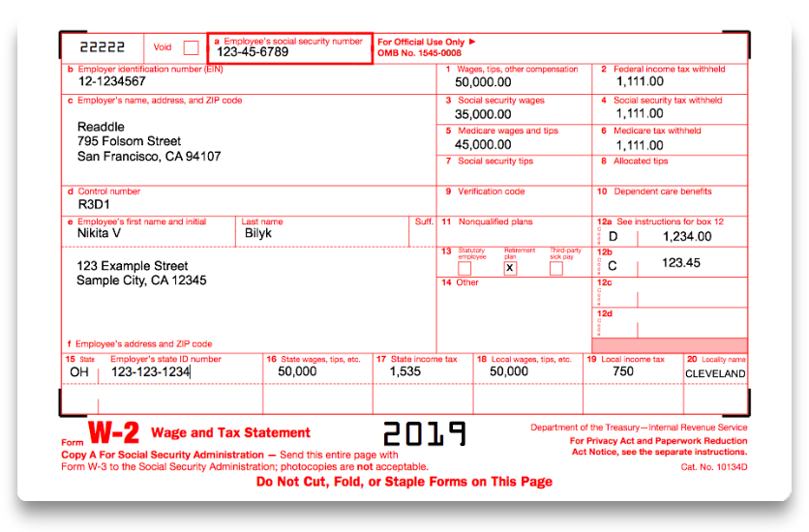On January 30th, Nikita Bilk received this W-2 form from her employer. How much did she pay in taxes during the year?

Amy Springfield works

for Pound Ridge Financial

Planners. Her employer uses

an electronic W-2 form as

shown at the right. What

accounts for the difference

between her wages listed

in Box 1 and her Social

Security and Medicare wages

listed in Boxes 3 and 5?

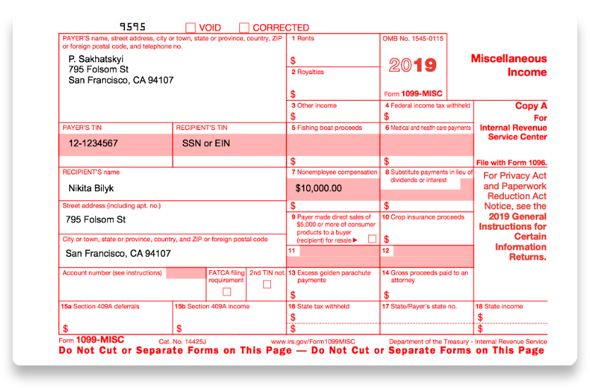**1099 Form**

Another type of income statement is the Internal Revenue Service’s Form 1099. This form is used to report different types of income other than wages, salaries, and tips such as bank interest, royalties, contracted work, and so on. Different 1099 forms are used depending upon the income type

Unlike the wages reported on the W-2 form, 1099 income has yet to be taxed. It will be added to the employee’s total income and used in the calculation of taxes when filling out the income tax return.

People don’t like paying taxes, but they realize it is a necessity to raise money for government services, and they cooperate with the procedure. This is known as **voluntary compliance**. You can lower your tax burden if you learn about taxes—the more you know, the more you can save.

On Form 1040A, you can report income from wages, interest, stock dividends, pensions, unemployment insurance, and Social Security benefits. There are many other sources of income a citizen can have, including alimony and prizes.

**Practice to fill in 1040 form**

Social Security Number 257-00-4321

Filing Status Head of Household

Taxpayer’s Date of Birth 03/01/1978 Taxpayer is not Blind or Deceased Client’s

First Name, Initial, and Last Name Whitney M. Refund

Street Address 4175 Spring Street Zip Code 30809 (Evans, Georgia)

Daytime Telephone 706-868-0985 E-Mail: whitneyrefund@yahoo.com Taxpayer’s Occupation Librarian

Dependent Information

Dependent Name Jeremy D. Refund Dependent’s Date of Birth 05/03/2012 Dependent’s SSN 364-00-5654 Relationship Son

Dependent Care Expenses $ 3800

Taxpayer has not released the claim for Jeremy to another person

Daycare Information Provider’s Name Sunshine House Provider’s EIN 589632100

Address 521 Furys Ferry Road -- Evans, GA 30809

Health Insurance Information Taxpayer had full-year minimum essential health care coverage.

Health care coverage was NOT purchased through the Exchange.

W-2 Information

Employer Identification Number 58-6412038

Employer Name/Address RCS 610 Ronald Reagan Drive Evans, GA 30809

Wages $ 26263 Federal Withholding $ 264

State GA State ID Number 28594178 State Tax Withheld $ 564 **

Stamp

Deductions lower your taxable income, which means you pay a lower income tax. Form 1040 allows some deductions from income, including some educational expenses. There are many deductions that the government allows taxpayers to use to lower the amount they pay in taxes, including

medical expenses alimony paid property taxes paid mortgage interest paid

state and local income taxes paid charitable contributions

casualty and theft losses gambling losses moving expenses

job-seeking expenses business expenses tax preparation fees

These deductions are filed using Form 1040, on an additional form, called **Schedule A—Itemized Deductions**. **Schedule B—Interest and Dividend Income** is used to list sources of interest and dividend income. It tells the IRS who paid you interest and dividends and how much you received from each.

**Assessment Target 20**

**I can…** Calculate federal income taxes using tax table and tax schedules

Fill in Form 1040, Schedule A, Schedule B







